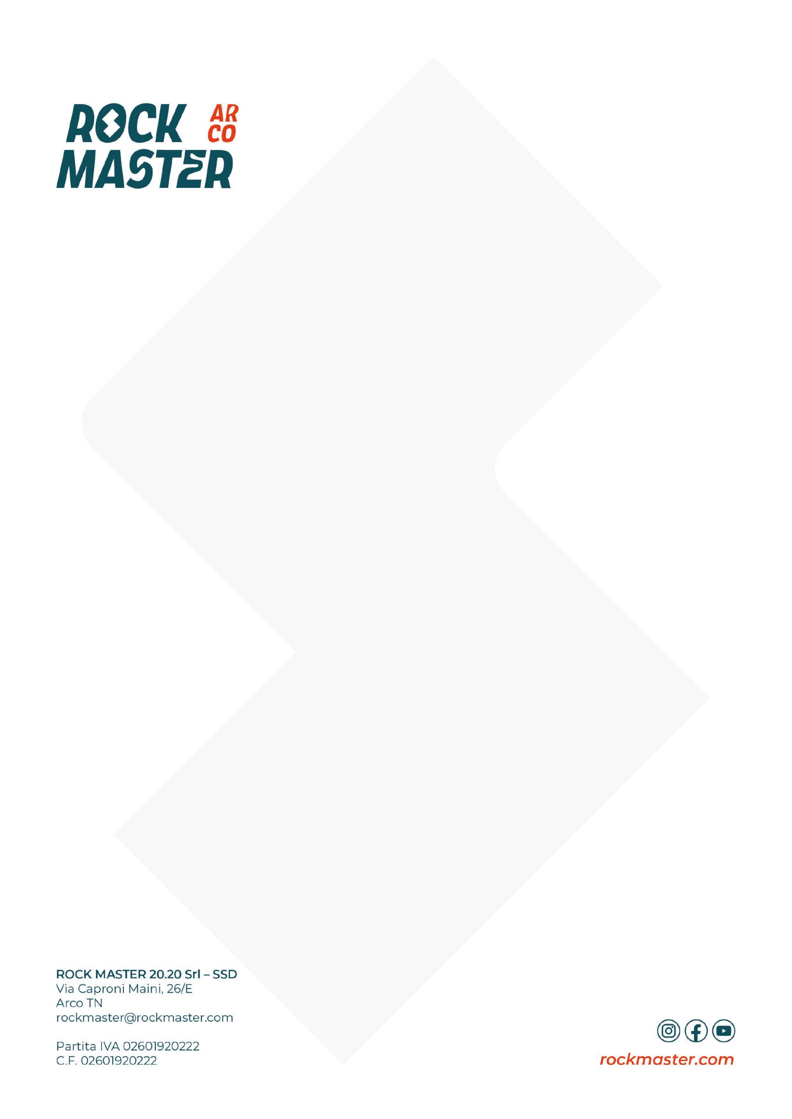
PROGRAMMA

VENERDÌ 2 OTTOBRE
14:00 – 20:00 Apertura Rock Master Village – Climbing Village
14:00 – 18:00 Let’s play – Climbing Village
15:00 Inaugurazione ufficiale – Climbing Village
15:30 – 16:30 Prove duello Lead donne – Climbing Stadium
16:30 – 17:30 Prove duello Lead uomini – Climbing Stadium
17:00 Climbin’ Espresso con Lynn Hill – Piazza III Novembre
18:00 Yoga for climbers con Sara Grippo – Yoga Garden
18:00 Climbing Talk - Dietro la parete: il lavoro dei tracciatori – Climbing Village
19:00 – 19:30 Presentazione atleti & bib draw – Climbing Village
20:00 Qualifiche Duello Lead – Climbing Stadium
21:15 – 22:15 Finali Duello Lead – Climbing Stadium
22:15 – 24:00 Warm up Party by Skylotek – Climbing Village

SABATO 3 OTTOBRE
10:00 – 20:00 Apertura Rock Master Village – Climbing Village
10:00 – 19:00 Let’s play – Climbing Village
10:00 – 12:30 CleanUp Rock Master – Massi di Prabi
10:00 – 11:00 Prove KO Boulder donne – Climbing Stadium
11:00 – 12:00 Prove KO Boulder uomini – Climbing Stadium
10:30 Yoga for climbers con Giorgia Benecchi – Yoga Garden
11:00 Climbin’ Espresso con Yuji Hirayama – Piazza Segantini
12:00 Climbing Talk - SportRoccia: Bardonecchia & Arco – Climbing Village
14:00 Climbing Talk – Cody Roth: Leaving Happiness Behind – Climbing Village
15:00 Climbing Talk - Savage Climbing: innovazione in parete – Climbing Village
15:00 - 17:00 FASI Speed Record Hunters – Climbing Stadium
16:00 Climbing Talk - SKYLOTEC Talk con Nicola Tondini: Pilastro Renato – Climbing Village
17:00 Rock Master Rewind: the big '80s photo – Climbing Stadium
17:30 – 19:00 Meet the masters: 40 anni Rock Master – Climbing Stadium
20:00 – 22:00 KO Boulder – Climbing Stadium
22:00 Sessione autografi – Climbing Stadium
22:15 - 01:00 Rock Master Rewind by La Sportiva – Climbing Village

DOMENICA 4 OTTOBRE
09:00 Yoga for climbers con Giorgia Benecchi – Yoga Garden
09:00 – 12:00 The Fun Bloc: amatori – Climbing Stadium
10:00 – 18:00 Apertura Rock Master Village – Climbing Village
10:00 – 18:00 Let’s play – Climbing Village
10:00 Climbin’ Espresso con Didier Raboutou e Robyn Erbesfield – Biblioteca Civica
11:00 Climbing Talk – Miriam Fogu & Giulia Medici: Amiche e Rivali – Climbing Village
12:00 – 13:30 Rock Master Legacy Talk – 40 anni di storia – Climbing Village
12:00 The Fun Bloc U15: Warm-up – Climbing Stadium
12:30 The Fun Bloc U15: Technical Meeting – Climbing Stadium
13:30 – 16:00 Qualificazioni The Fun Bloc U15 – Climbing Stadium
16:15 – 16:45 The Fun Bloc U15: Prova dei blocchi di finale – Climbing Stadium
17:15 – 18:00 Finale The Fun Bloc U15 – Climbing Stadium
18:00 Goodbye Rock Master – Climbing Village

