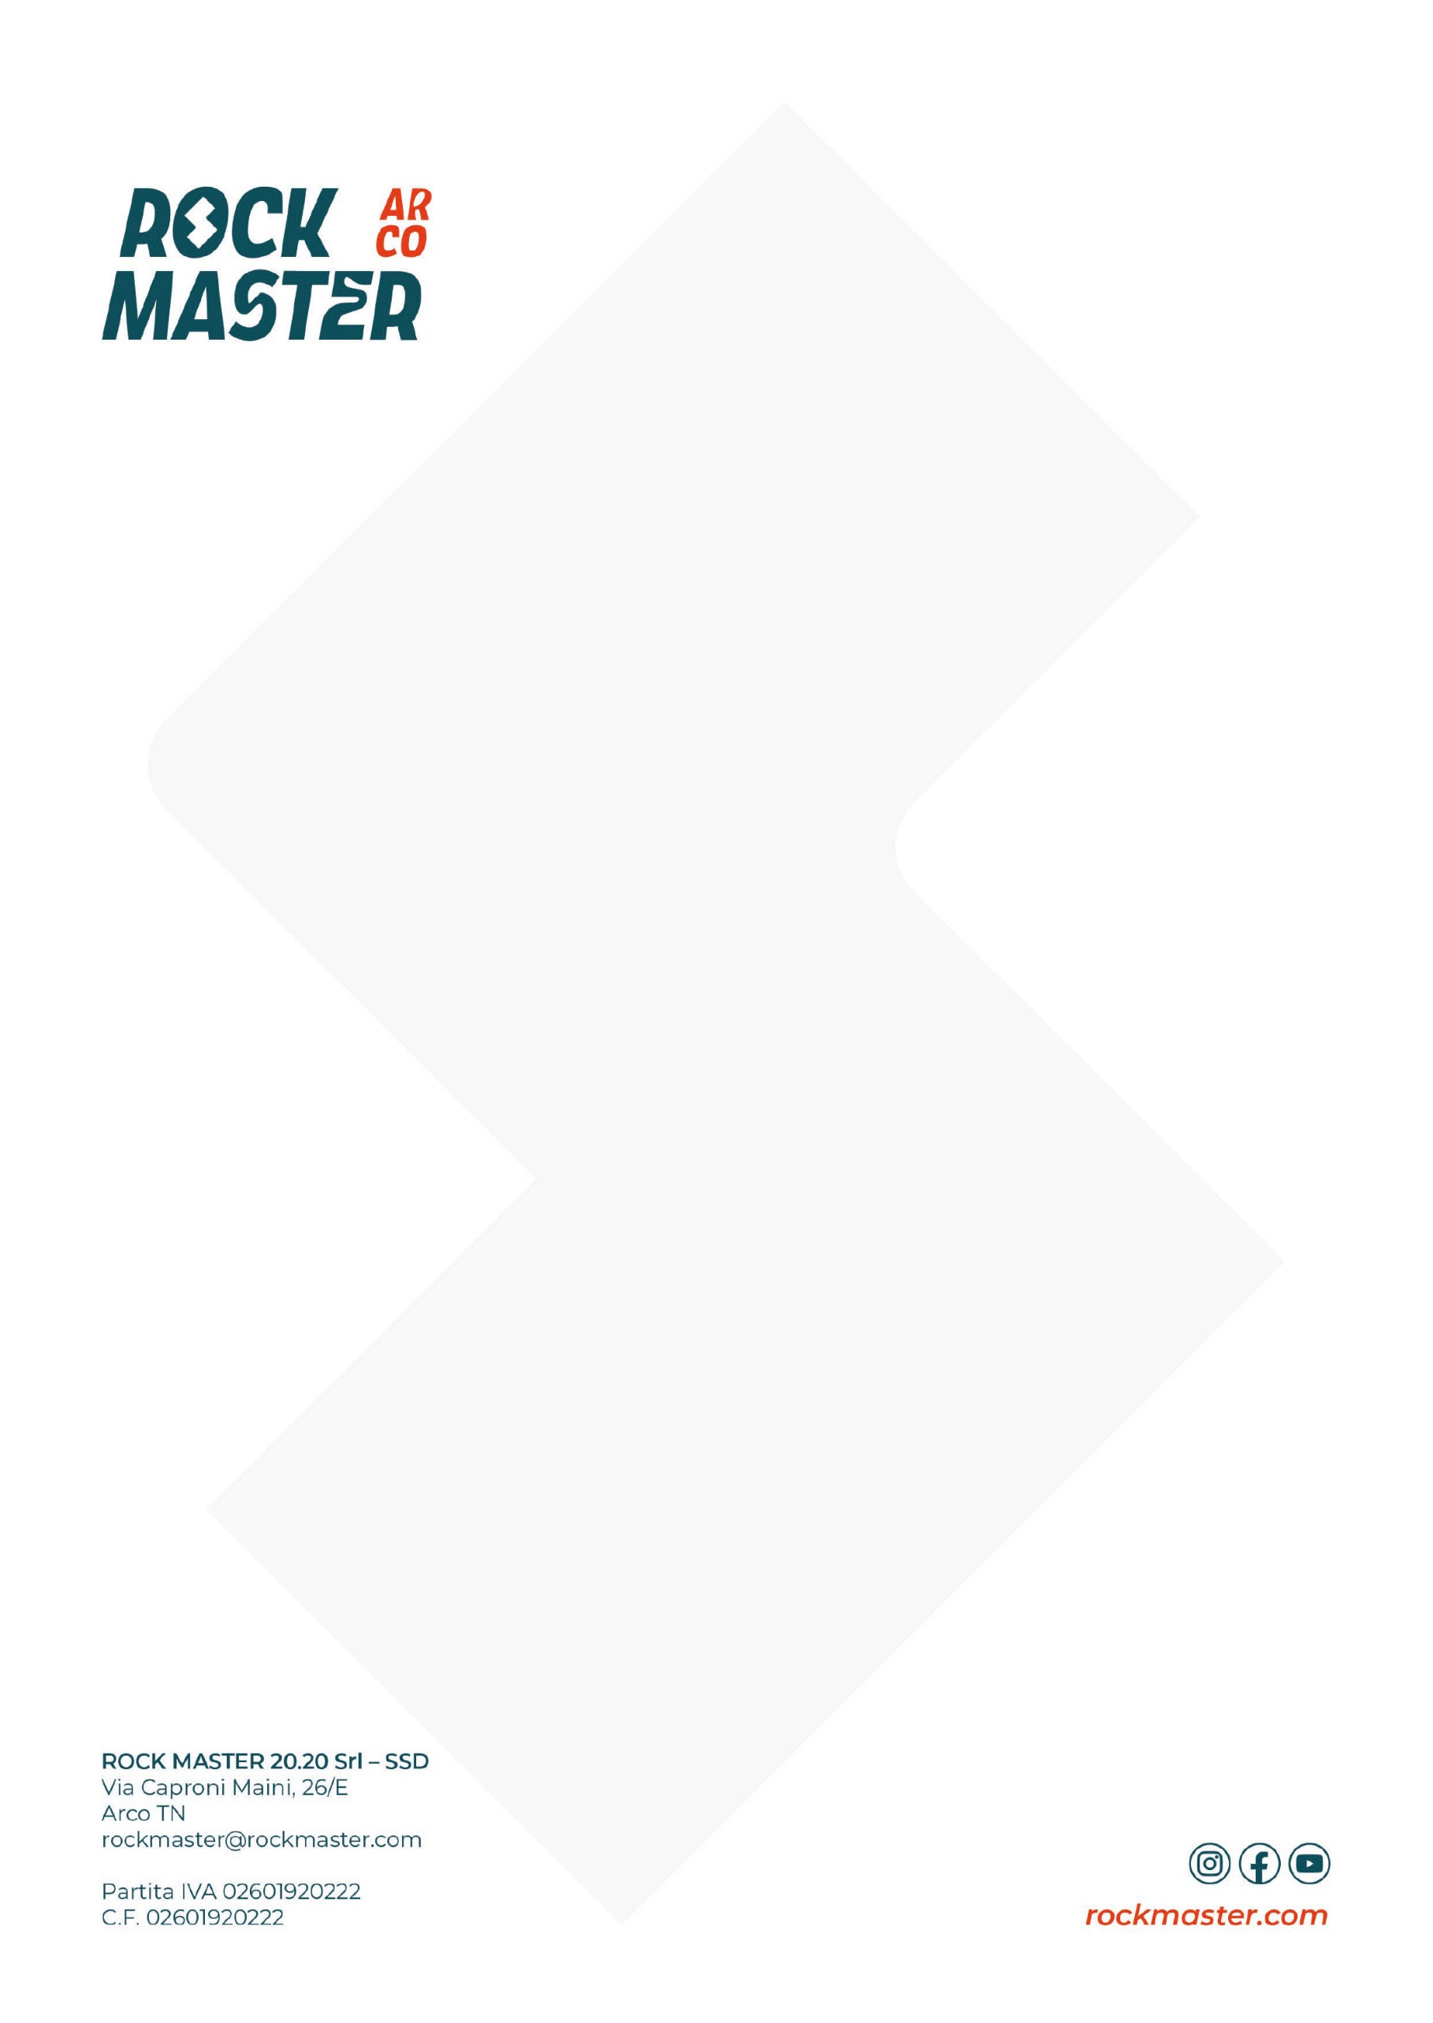
PROGRAMME

FIRDAY, OCTOBER 2
14:00 – 20:00 Rock Master Village opening – Climbing Village
14:00 – 18:00 Let’s play – Climbing Village
15:00 Official opening ceremony – Climbing Village
15:30 – 16:30 Lead Duel women’s warm-up – Climbing Stadium
16:30 – 17:30 Lead Duel men’s warm-up – Climbing Stadium
17:00 Climbin’ Espresso with Lynn Hill – Piazza III Novembre
18:00 Yoga for climbers with Sara Grippo – Yoga Garden
18:00 Climbing Talk – Behind the Wall: The Work of the Route Setters – Climbing Village
19:00 – 19:30 Athlete presentation & bib draw – Climbing Village
20:00 Lead duel qualifications – Climbing Stadium
21:15 – 22:15 Lead duel finals – Climbing Stadium
22:15 – 24:00 Warm up Party by Skylotek – Climbing Village

SATURDAY, OCTOBER 3
10:00 – 20:00 Rock Master Village opening – Climbing Village
10:00 – 19:00 Let’s play – Climbing Village
10:00 – 12:30 CleanUp Rock Master – Massi di Prabi
10:00 – 11:00 KO Boulder women’s practice sessions – Climbing Stadium
11:00 – 12:00 KO Boulder men’s practice sessions – Climbing Stadium
10:30 Yoga for climbers with Giorgia Benecchi – Yoga Garden
11:00 Climbin’ Espresso with Yuji Hirayama – Piazza Segantini
12:00 Climbing Talk - SportRoccia: Bardonecchia & Arco – Climbing Village
14:00 Climbing Talk – Cody Roth: Leaving Happiness Behind – Climbing Village
15:00 Climbing Talk – Savage Climbing: Innovation on the Wall – Climbing Village
15:00 – 17:00 FASI Speed Record Hunters – Climbing Stadium
16:00 Climbing Talk - SKYLOTEC Talk with Nicola Tondini: Pilastro Renato – Climbing Village
17:00 Rock Master Rewind: the big '80s photo – Climbing Stadium
17:30 – 19:00 Meet the masters: 40 anni Rock Master
20:00 – 22:00 KO Boulder – Climbing Stadium
22:00 Signature session – Climbing Stadium
22:15 - 01:00 Rock Master Rewind by La Sportiva – Climbing Village

SUNDAY, OCTOBER 4
09:00 Yoga for climbers with Giorgia Benecchi – Yoga Garden
09:00 – 12:00 The Fun Bloc: amateurs – Climbing Stadium
10:00 – 18:00 Rock Master Village opening – Climbing Village
10:00 – 18:00 Let’s play – Climbing Village
10:00 Climbin’ Espresso with Didier Raboutou and Robyn Erbesfield – Biblioteca Civica
11:00 Climbing Talk – Miriam Fogu & Giulia Medici: Friends and Rivals – Climbing Village
12:00 – 13:30 Rock Master Legacy Talk – 40 years of history – Climbing Village
12:00 The Fun Bloc U15: Warm-up – Climbing Stadium
12:30 The Fun Bloc U15: Technical Meeting – Climbing Stadium
13:30 – 16:00 The Fun Bloc U15 Qualifications – Climbing Stadium
16:15 – 16:45 The Fun Bloc U15: Practice session on the Final boulders – Climbing Stadium
17:15 – 18:00 The Fun Bloc U15 Finals – Climbing Stadium
18:00 Goodbye Rock Master – Climbing Village

